**Parasite Prevention and Control**

Types of Parasites

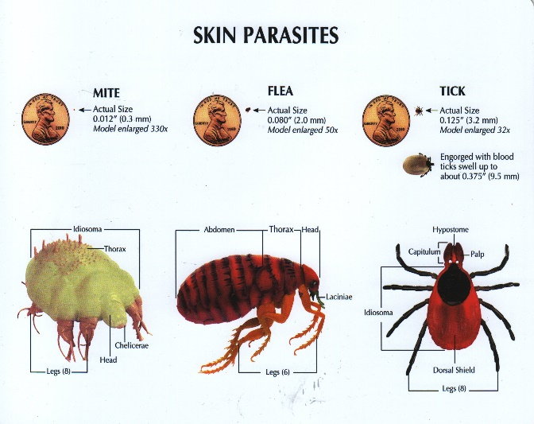External

* Fleas
* Ticks
* Ear Mites
* Sarcoptic Mange
* Demodectic Mange

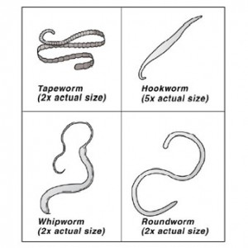Internal

* Roundworms
* Whipworms
* Hookworms
* Tapeworms
* Coccidia
* Heartworms

**Types of Prevention and Control**





